Unit I
Introduction to Artificial Intelligence

(6 Hours)

1.1 Introduction to AI, AI Perspectives: Acting and thinking humanly, Acting and thinking rationally
1.2 Scope of AI
1.2.1. Game Playing
1.2.2. Problem Solving:
1.2.3. Natural Language Processing
1.2.4. Robotics
1.2.5. Computer Vision
1.2.6. Expert Systems
1.3 Turing Machine and Turing Test
1.4. Intelligent Agents, Structure of Intelligent agent, Properties of Intelligent Agents

Case Example: “SmartFarm AI – Helping a Farmer with Artificial Intelligence”
- Ramesh is a farmer in Nepal.
- He grows tomatoes, potatoes, and rice on his small farm.
- Every year, he faces problems with plant diseases.
- Sometimes his crops get damaged before he even notices it.
- He loses a lot of money due to late detection of crop disease.
- He wishes he could get early warnings before his plants die.
- One day, his friend tells him about SmartFarm AI, a mobile app that uses Artificial Intelligence.
- The app can identify plant diseases from photos taken by the farmer.
- Ramesh decides to try it out.
- He opens the app and takes a photo of an infected tomato leaf.
- The app immediately analyzes the photo.
- It detects brown spots and discolored edges on the leaf.
- Within a few seconds, it says:
- “Your plant may have Early Blight disease.”
- It also shows what medicine to use and how to prevent it next time.
- Ramesh is surprised and happy.
- He realizes this is Artificial Intelligence at work.
- But what exactly is happening inside the app?
- Let’s break it down to understand how AI helps Ramesh.

Part 1: How the AI Works
- The app uses a camera (sensor) to capture the image.
- The photo is sent to a computer model trained on thousands of leaf images(ML).
- The model has learned from past data to recognize patterns of healthy and infected leaves.
- The computer compares Ramesh’s leaf with known examples in its database.
- It uses a machine learning algorithm to predict the disease.
- The algorithm gives a result: “Early Blight, 95% confidence.”
- It then generates suggestions and sends them back to Ramesh’s phone.
- The app acts as an intelligent agent — it perceives, thinks, and acts.
- The AI doesn’t just see colors; it interprets meaning — like a human would.
- It has learned from experience, not by being told every rule manually.
- That’s what makes it “intelligent.”

Part 2: Difference Between Human and AI Thinking
- If a human expert saw the leaf, he would:
- Observe the color and texture.
- Recall past experiences of plant diseases.
- Think logically and emotionally (“I’ve seen this disease before”).
- Then decide which treatment to apply.
- The AI system, on the other hand:
- Doesn’t have feelings or experience pain or stress.
- It just processes the image mathematically.
- It calculates similarity scores and probabilities.
- It uses stored data and algorithms instead of emotions.
- It works faster but only in the field it was trained for.
- If the app is shown a banana leaf (not in its training data), it may fail.
- So, humans are flexible and adaptive — AI is powerful but limited.
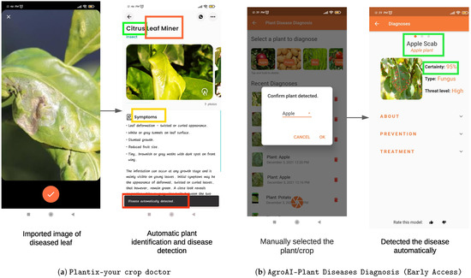

Part 3: Understanding AI Perspectives through this Case

1. Acting Humanly
- The app acts like a human plant expert.
- It observes the leaf, identifies the problem, and gives a solution.
- Ramesh talks to it like a person — “What’s wrong with my plant?”
- The app responds naturally, like a conversation.
- It passes the “acting humanly” test because Ramesh feels like he’s talking to an expert.

2. Thinking Humanly
- The AI “thinks” by simulating how a human reasons.
- It doesn’t just store pictures — it looks for patterns and causes.
- For example, it identifies that brown spots usually mean fungus.
- It has learned cause-and-effect relationships like humans do.
- It “thinks” but without emotions or fatigue.

3. Acting Rationally
- The AI tries to choose the best action for the situation.
- It doesn’t panic or guess randomly.
- It analyzes data and selects the most effective disease treatment.
- That’s rational action — doing what maximizes success.
- Humans might hesitate or delay, but AI acts immediately.

4. Thinking Rationally
- The app uses logic and rules behind the scenes.
- For example:
- IF leaf has dark circular spots AND yellow edges, THEN disease = Early Blight.
- These are logical rules that follow the “laws of thought.”
- It reasons step by step to reach a conclusion.

Part 4: Inside the Intelligent Agent
- The app behaves as an Intelligent Agent.
- It perceives the environment using its camera.
- It reasons using algorithms and learned knowledge.
- It acts by giving the user advice and actions.
- It can even improve with feedback — a key property of learning agents.
- Over time, as more farmers use the app, the model becomes smarter.
Agent Components:
70. Sensor → Camera (captures leaf image)
71. Processor → AI model (analyzes the data)
72. Actuator → App interface (shows diagnosis and advice)
Properties:
73. Autonomy — works on its own.
74. Reactivity — responds to user input quickly.
75. Proactiveness — gives preventive advice before diseases occur.
76. Rationality — chooses best solution with available information.
77. Learning — improves through continuous data updates.

Part 5: How AI Learns Like a Student
- AI learning is similar to how a student studies for exams.
- Suppose you show a student 100 pictures of diseased leaves.
- The student learns to recognize patterns — shapes, colors, textures.
- Then you test them with a new image.
- If they recognize it correctly, they’ve learned.
- Similarly, AI uses “training data” and “testing data.”
- The more examples it sees, the better it gets.
- But unlike humans, AI can learn from millions of examples in minutes.

Part 6: Expanding AI in the Farm
- SmartFarm AI doesn’t stop at disease detection.
- It also uses AI to predict weather conditions.
- It combines data from satellites and local sensors.
- The AI forecasts rainfall, temperature, and humidity.
- It alerts Ramesh: “Heavy rain tomorrow, avoid spraying chemicals.”
- It helps him plan his work smarter.
- The AI is like a “digital assistant farmer.”

Part 7: How Humans and AI Work Together
- Humans have intuition and creativity.
- AI has data and computation power.
- Together, they form a strong partnership.
- Ramesh still decides what to do, but the AI helps him make better choices.
- The AI learns patterns faster, but Ramesh knows his farm better.
- So both intelligence types complement each other.

Part 8: Advantages of AI in this Case
- Early detection of diseases.
- Saves time and effort.
- Reduces crop loss and increases productivity.
- Provides consistent advice without fatigue.
- Works 24/7 and improves continuously.

Part 9: Limitations of AI
- Depends on quality of data and internet connection.
- May fail if shown something completely new.
- Cannot replace human judgment or creativity.
- Needs updates and maintenance regularly.
- May be costly for small farmers initially.

Part 10: Learning from the SmartFarm Example
- Through this example, we can understand AI concepts easily.
- It shows AI is not magic, it’s logic and learning combined.
- Machines are powerful because they follow rules without getting tired.
- But they lack feelings and social understanding.
- Humans, on the other hand, can feel empathy and make moral decisions.
- The goal of AI is not to replace humans but to assist them.
- AI augments human intelligence — not competes with it.

Learning Points
- SmartFarm AI acts humanly — like an agricultural expert.
- It thinks humanly — by recognizing disease patterns.
- It acts rationally — choosing the best solution.
- It thinks rationally — using logical rules.
- It behaves like an intelligent agent with perception, reasoning, and action.
- The Turing Test concept can be applied — if Ramesh can’t tell if advice came from a person or AI, it’s intelligent.
- This is how AI makes real-world impact.
- Farmers, doctors, teachers, and engineers can all use AI tools similarly.

In Summary
- Humans and AI are both intelligent in their own ways.
- Humans are creative, emotional, and adaptive.
- AI is logical, fast, and precise.
- Together, they can solve big problems — like hunger, disease, and education.
- Ramesh’s SmartFarm AI shows how intelligence can be shared between man and machine.
- Artificial Intelligence is not just technology — it’s the next step in human innovation.
- Understanding how AI works in simple examples helps us use it responsibly.

1.1 Introduction to Artificial Intelligence
Artificial Intelligence (AI) is a branch of computer science that focuses on creating machines capable of performing tasks that require human-like intelligence such as reasoning, learning, decision-making, perception, and understanding natural language.
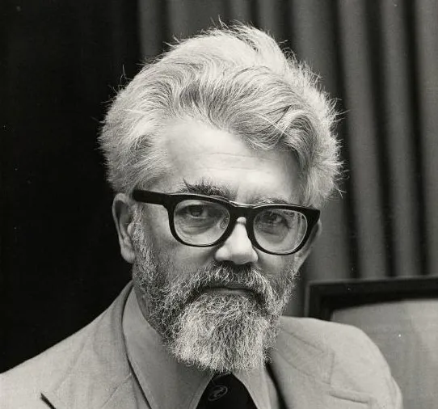
Origin:
The term Artificial Intelligence was first introduced by John McCarthy in 1956 during the Dartmouth Conference.

Objectives of AI:
- To build systems that can simulate human thinking and behavior.
- To design machines that can solve complex problems intelligently.
- To enable computers to learn from experience and adapt to new situations.
- To automate reasoning and improve human decision-making.

Examples of AI Applications:
- Virtual assistants (Siri, Alexa, Google Assistant)
- Self-driving cars
- Recommendation systems (Netflix, YouTube)
- Fraud detection in banking
- Smart home automation

AI Perspectives
Artificial Intelligence can be viewed from four main perspectives that describe how a system can behave or think intelligently.

1. Acting Humanly (The Turing Test Approach)
- Proposed by Alan Turing (1950).
- Focuses on building systems that behave like humans.
- The Turing Test evaluates whether a machine can exhibit human-like behavior that is indistinguishable from a person.
- If a human evaluator cannot differentiate the machine’s responses from a human’s, the machine is said to possess intelligence.
- Example: Chatbots or virtual assistants that communicate naturally with humans.
Key Idea:
If a machine can act humanly, it can be considered intelligent.

2. Thinking Humanly (The Cognitive Modeling Approach)
- Tries to model how humans think and reason.
- Involves understanding the human brain and replicating its functions using computational models.
- Often data from cognitive psychology and neuroscience is used.
- Example: Neural networks and cognitive architectures that mimic brain processing.
Key Idea:
AI should think the same way humans do — by replicating mental processes like learning and memory.

3. Acting Rationally (The Rational Agent Approach)
- Focuses on designing intelligent agents that act to achieve the best possible outcome in any given situation.
- A rational agent perceives its environment and takes actions to maximize performance or success.
- Example: Self-driving cars choosing the safest and most efficient path.
Key Idea:
Intelligence means choosing and executing the best possible action based on goals and knowledge.

4. Thinking Rationally (The Laws of Thought Approach)
- Based on the use of logic and reasoning to make decisions.
- Derived from the principles of philosophy and mathematics (e.g., Aristotle’s logic).
- AI systems are designed to reason correctly using logical rules and formal proofs.
- Example: Expert systems that use rule-based reasoning to diagnose diseases.
Key Idea:
AI should think logically and rationally — following correct principles of reasoning to reach conclusions.

